**Backpropogation**

In artificial neural networks we use backpropagation to calculate a gradient that is needed in the calculation of the weights to be used in the network. This method is used to train deep neural networks i.e. networks with more than one hidden layer. It is equivalent to automatic differentiation in reverse accumulation mode. It requires the derivative of the loss function with respect to the network output to be known, which typically (but not necessarily) means that a desired target value is known. For this reason it is considered to be a supervised learning method.

**LVQ**

LVQ stands for Learning Vector Quantization. It is a prototype-based supervised classification algorithm. LVQ is the supervised counterpart of vector quantization systems.

**Procedure**

**Pre- Processing**

In the obtained database the image resolution is 680x480. If we take this as input then the total number of inputs will be 326,400 and we will be running it through multiple epoch which will take a lot of time and a lot computing power. Therefore to save time we decrease the resolution and take image size 50x50 and crop only the faces so that it gives us better results.

Each photo is converted to grey-scale. This gives us image in form of an array with value ranging from 0 to 255 in single array element. If we directly send this as input then again it will take a lot of time as well as value of weights will be very high so we set a threshold. If the value is above it then the cell value is +1 else -1.

If we take threshold 127 then with slight change in lighting the result can change drastically. So to avoid it we have use Adaptive Threshold Method(Gaussian).In Gaussian Adaptive Threshold, value is the weighted sum of neighbourhood values where weights are a Gaussian window.

[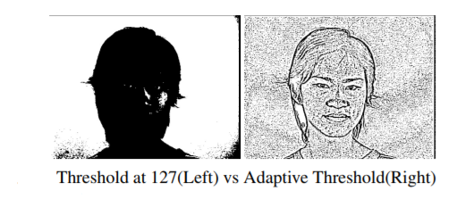](https://github.com/harshmittal2210/Face-Recognition-using-Neural-Network/blob/master/images/compare.PNG)

**Training**

For training we have taken 1050 input images(650 positive and 400 negative images). For a single image we have 2500 input nodes which are then passed to 200 hidden nodes and finally there are 2500 output nodes.Target value for the BPN is given as the image itself. In this process BPN is used as auto-associative network. Here BPN is used to extract features of face from the image.

[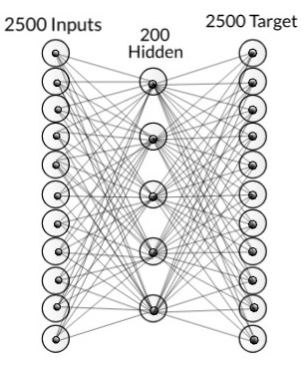](https://github.com/harshmittal2210/Face-Recognition-using-Neural-Network/blob/master/images/bpn.jpeg)

Network with just BPN

After the network is trained then the hidden nodes are taken as input and pass on to another network in which it is separated by using LVQ. The output has two nodes which tells whether the face is present or not. This is passed to another layer which is then passed to a activation function. This is the final output which tells us the probability of face present in that image.

[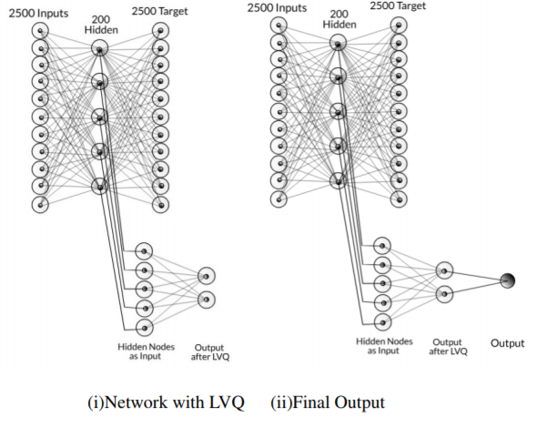](https://github.com/harshmittal2210/Face-Recognition-using-Neural-Network/blob/master/images/train.PNG)

This whole process takes about 2hr to train the model(For 10 epoch per image). If we increase the number of epochs then the result will improve but the time taken will increase drastically(This might not be true for al the cases as at some point the error becomes constant and do not decreases).

All the trained data-set i.e weights are stored using pickle and gzib library.

[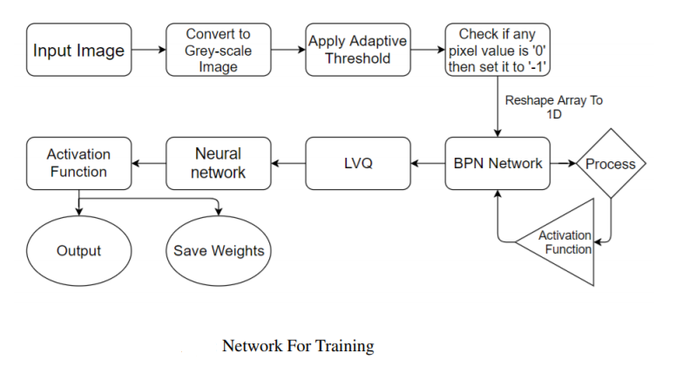](https://github.com/harshmittal2210/Face-Recognition-using-Neural-Network/blob/master/images/network.PNG)

**Testing**

For testing purpose from the database we had already separated 550 images for testing which were not used as training database. We tested on around 550 positive images and 400 negative images. These images are also scaled to 50x50 in order to test.

As for the output mean result for positive training database the output had a value of 1.16 and for negative it was around 0.43.

[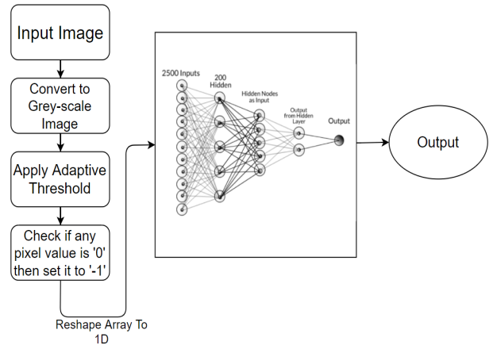](https://github.com/harshmittal2210/Face-Recognition-using-Neural-Network/blob/master/images/testnetwork.PNG)

For opening the pre-saved weights we use pickle library.

**Results**

Initially the accuracy was 61% when the output of hidden layer was considered as output. When another neural layer was attached then the accuracy increased to 65%. When the training data set was increased from 350 to 500 the accuracy increased to 72% and it takes around 0.096 sec to identify each image whether it is having a face or not.

This kind of network works better for identifying the identity of the person instead of detecting whether it is a face or not. Since this networks on extracting features and based on them give the output therefore it can be trained to give the identity of a person in form of binary or hexadecimal value.

Moreover if we want to further improve the accuracy for face detection then we will have to increase the number of hidden layer but because of that the computation time will be higher and will not have real world application as it will take time to show the result.